Q1.
Two different companies manufacture a material. A researcher collected samples from both companies, each of size n=25
- Company 1: Xˉ1=20 milligrams/1000 cycles,S1=2 milligrams/1000 cycles—Company 2: Xˉ2=15 milligrams/1000 cycles,S2=8 milligrams/1000 cycles
- Given that the population variances are not assumed equal and significance level is α=0.05 Test whether the data support the claim that the companies produce material with different mean wear.
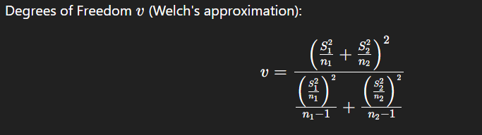
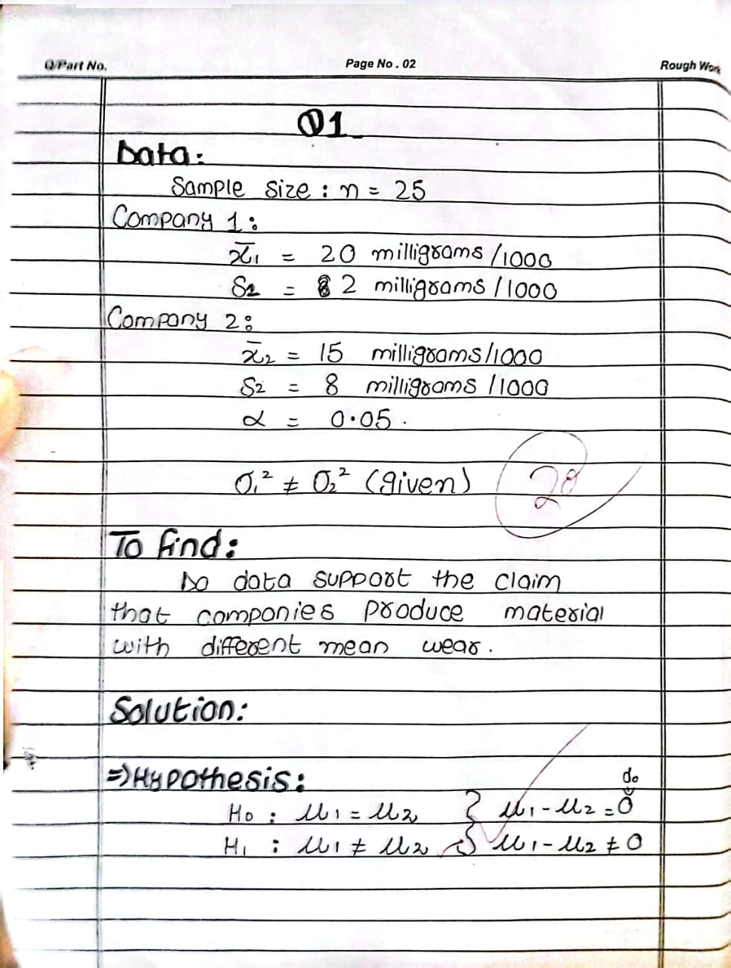
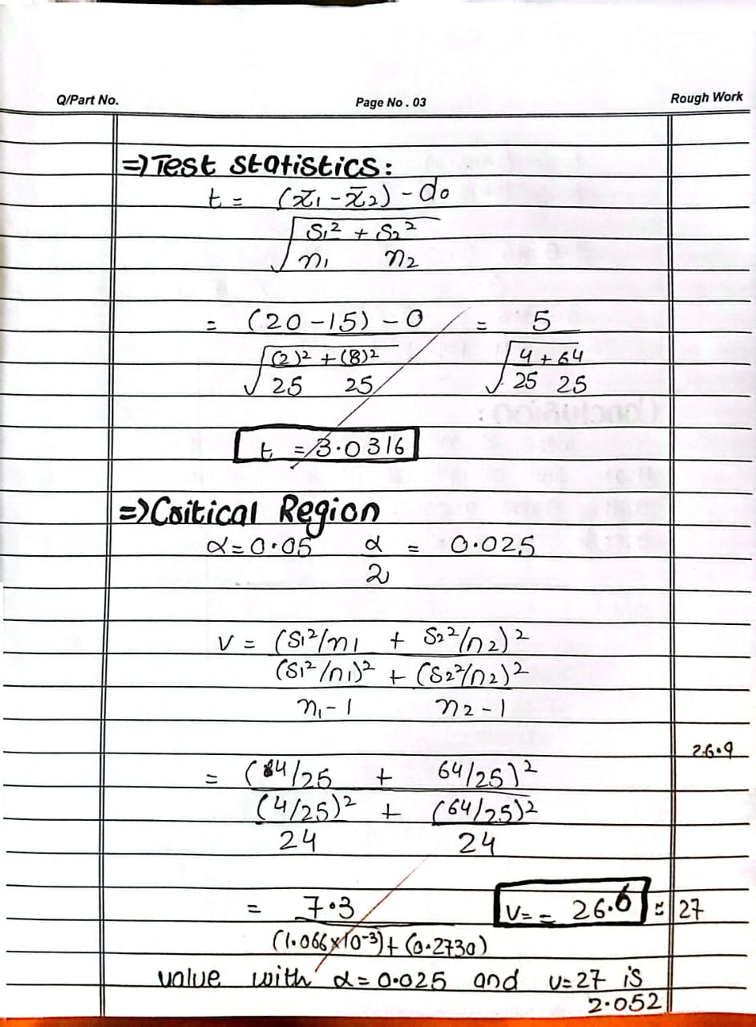
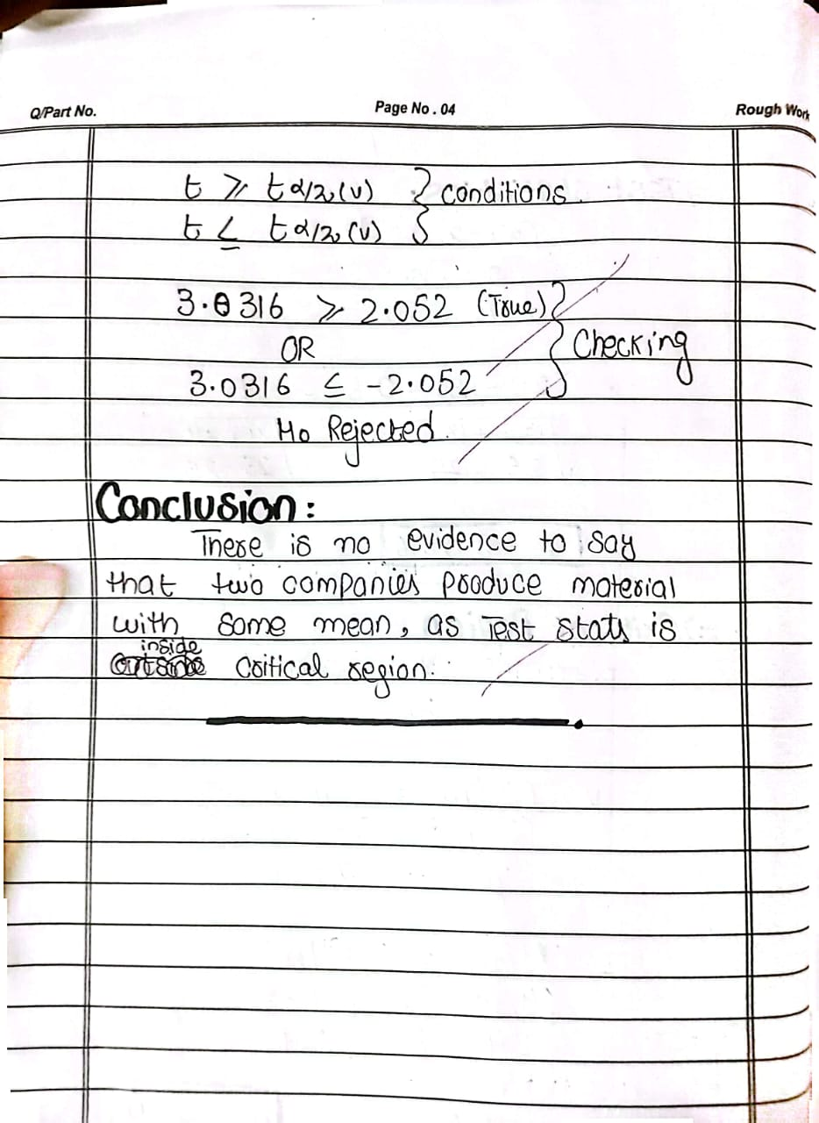
Q2.
A survey of 500 employees was conducted to examine the relationship between their job classification (Salaried or Hourly) and their preference for one of three pension plans The results are shown below:

The significance level is α=0.05. Test whether job classification and preference for pension plan are independent.
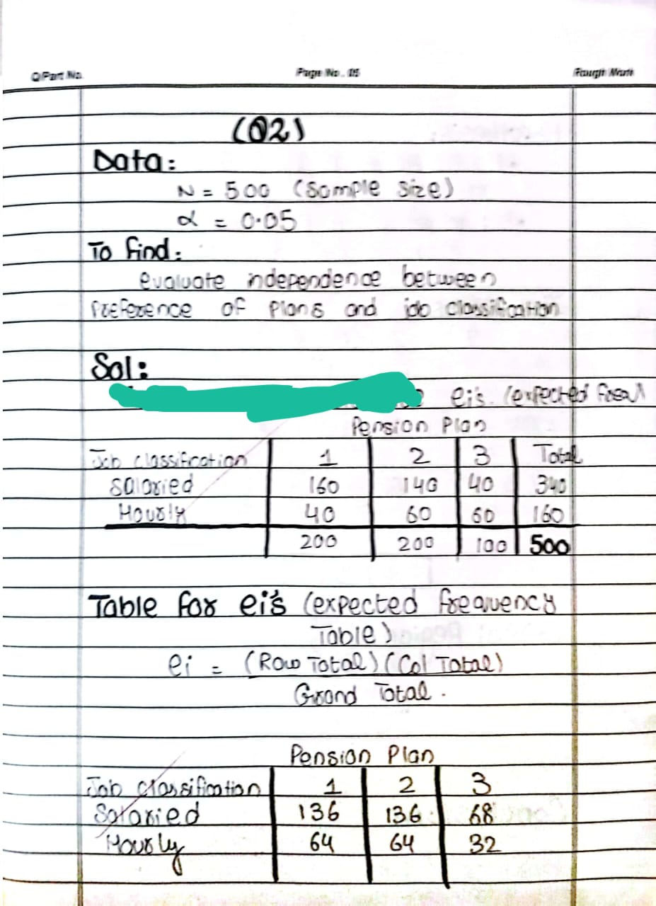
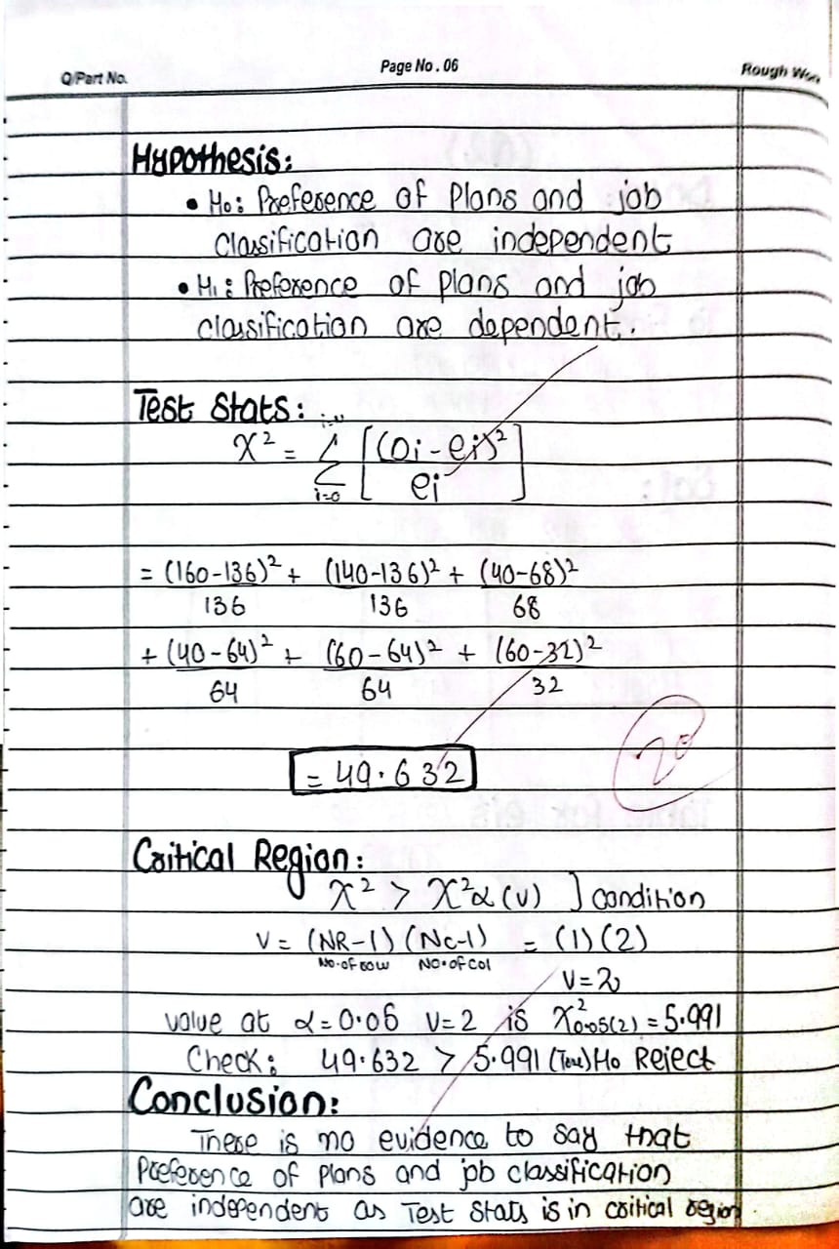
Q3.
Sample size: n=9.Data for x and y are given.
(a) Find the linear regression line of y on x.
(b) Estimate y^when x=85.
